Problem 1. Create a Java class Calculator that provides different ways to perform addition.

Include three methods: The first method takes two integer numbers, the second

method takes three integer numbers, and the third method takes two double

numbers. In the main method, create an object of Calculator class.

Code:

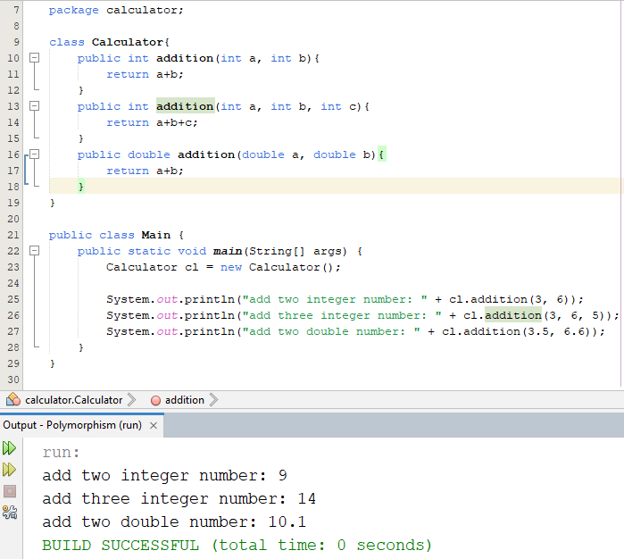

Problem 2. Create a Java class Shape that provides different ways to calculate the area. Include three methods: the first method takes one parameter (side length) to calculate the area of a square, the second method takes two parameters (length and width) to calculate the area of a rectangle, and the third method takes one decimal parameter (radius) to calculate the area of a circle. In the main method, create an object of Shape class.

Code :

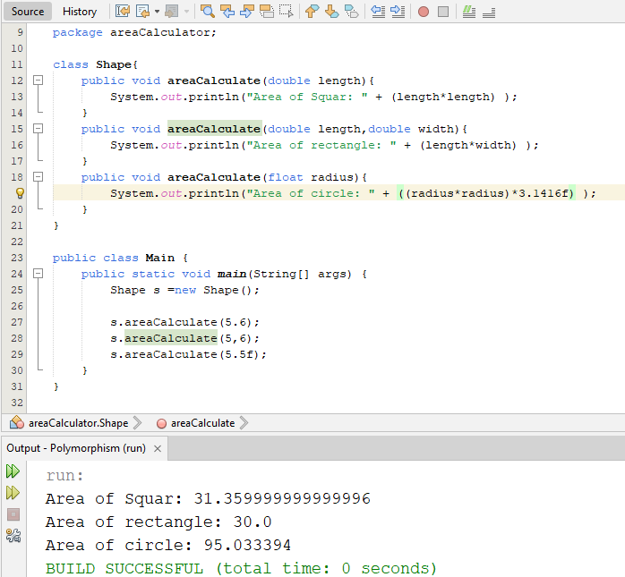

Problem 3. Write a Java program to define a class Employee with instance variables name and id, along with a method calculateSalary(). Create two subclasses, Worker and Supervisor, each having additional instance variables baseSalary and bonus. In both subclasses, override the calculateSalary() method to compute and return the salary.

Code:

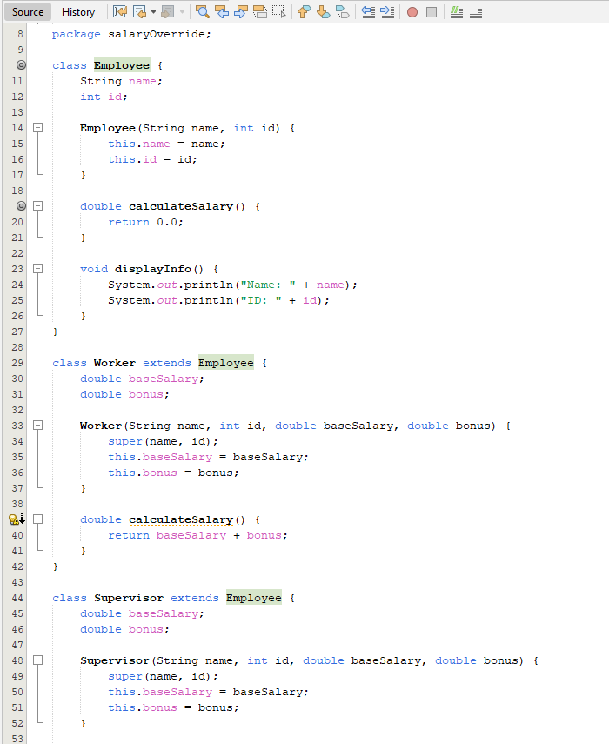

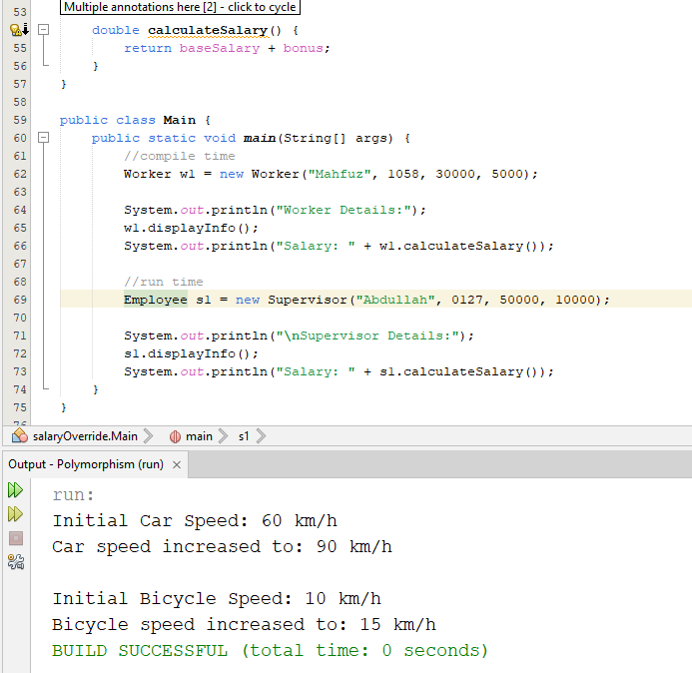

Problem 4. Write a Java program to define a class Vehicle with a method speedUp(). Create two subclasses: Car and Bicycle, each having an instance variable currentSpeed. In both subclasses, override the speedUp() method to increase the vehicle's speed differently.

Code:

